Meeting 27
Course / Class #: CECS 4800

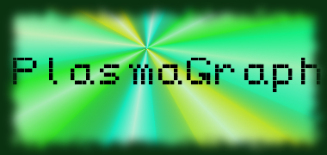
Date: 24 April 2014
Project Name: PlasmaGraph

Has been done:
- Test documentation first draft
- Tests with Matlab final Test Files. (Header column is being found but not used. Bug that will be fixed by next week's client meeting.)
- Began writing final presentation outlines for both Plasma Lab presentation and Final Project presentation.
- Client meeting scheduled for next week.
- Halfway done with Javadoc documentation polish.
What will be done:
- Remaining documentation. (SPMP, SRS, etc)
- Finish presentations, and start gathering materials and designing for project poster.
- Fix remaining bugs before meeting with client.
- Finish Javadoc polish.

Materials Used: 2x Computers, Internet connections, Microsoft Visio / Dia (Diagramming Tools), Eclipse / NetBeans IDE (Programming Tools).

Group Members: ________________________________
Gerardo A. Navas

________________________________
Daniel Quintini
Professor:

________________________________
Prof. Luis A. Ortiz

